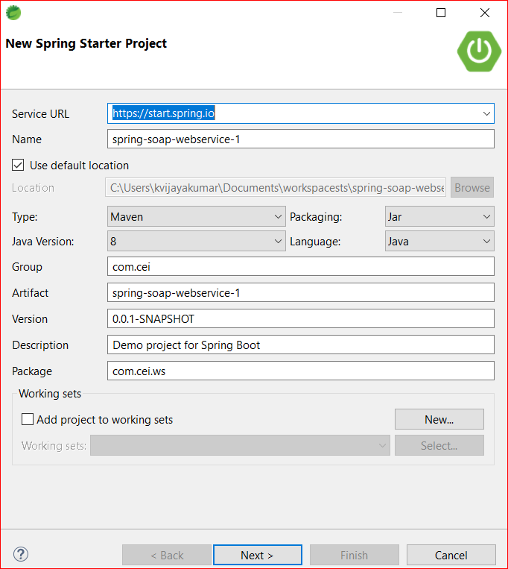

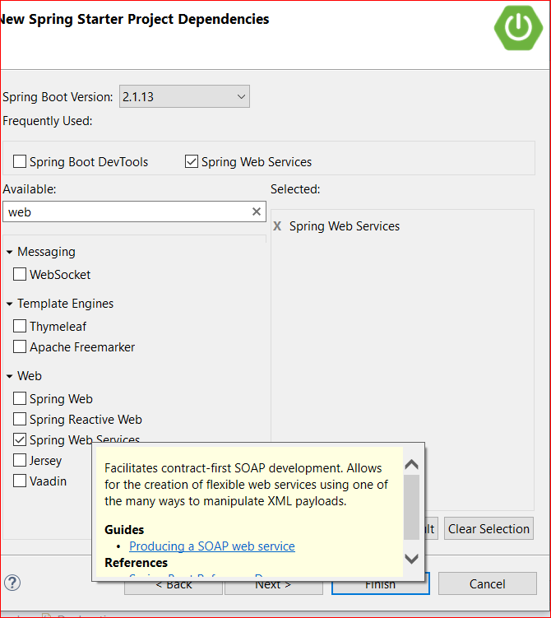

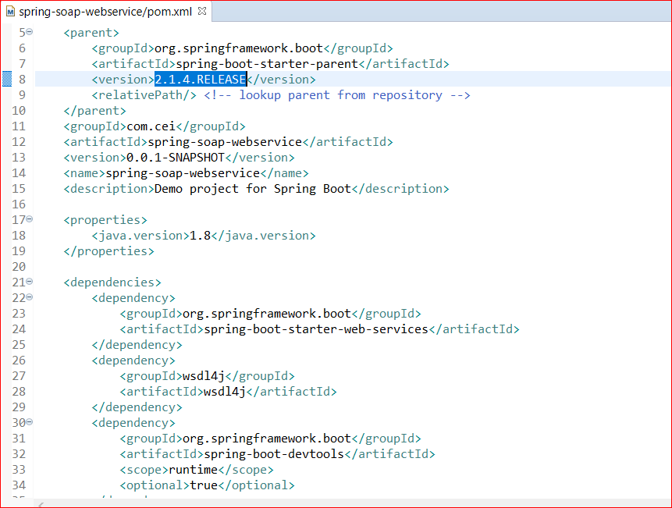

Wsdl4j to work with spring base soap webservices.

As we are using contract first approach we need to write the wsdl file. Since we are using spring boot here we need to write only xsd file. Schema definition.

XSD file will contains the structure of your input request and response.

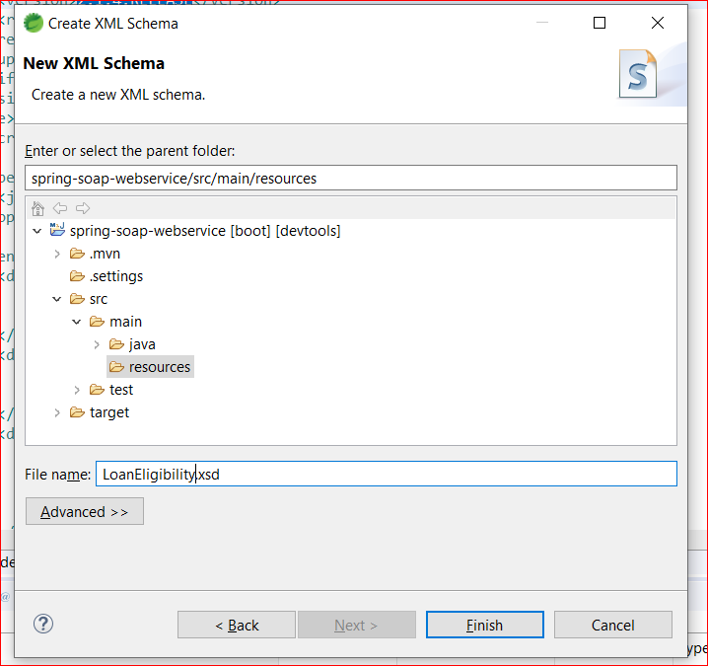

We need add our own xsd with request and response.

So lets add

Target name space similar to package in java

Xmls:tns short name for the target name space.

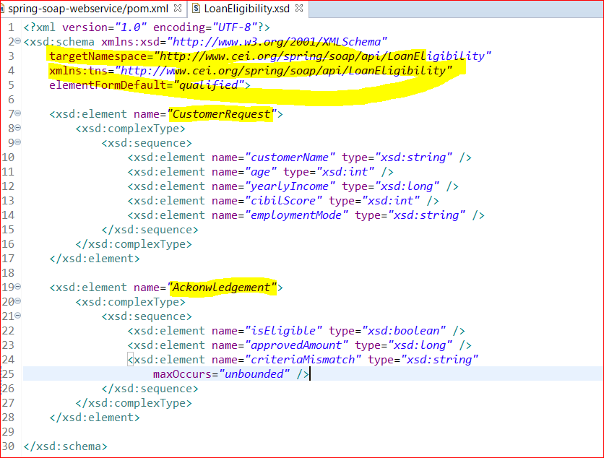

CustomerRequest is my class and other variable are elements

In Acknowledgement I have criteriaMismatch as list of string that is maxOccurs is unbounded.

This xsd is your complete skeleton of your input request and response.

Now we need to generate our binding java classes from the xsd.

To generate binding classes from schema definition file xsd we need to add a plugin in build section of pom.xml

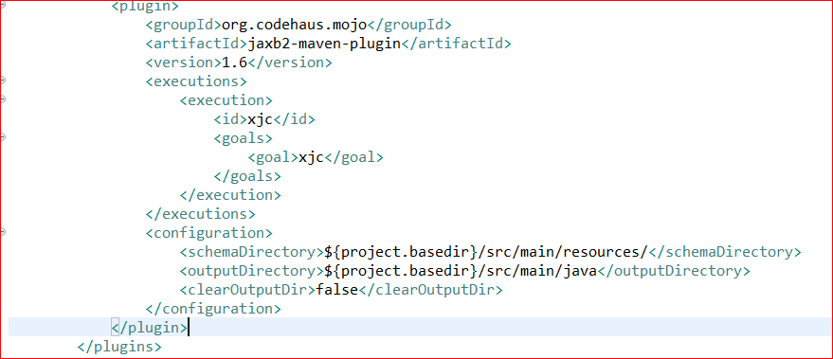

If we look at the schema directory it is pointed to resources and output directory is main/java. So binding classes will get generated at main/java

Based on the target name space the xjc plugin will help to create the package (*http://www.cei.org/spring/soap/api/LoanEligibility)* and the binding classes.

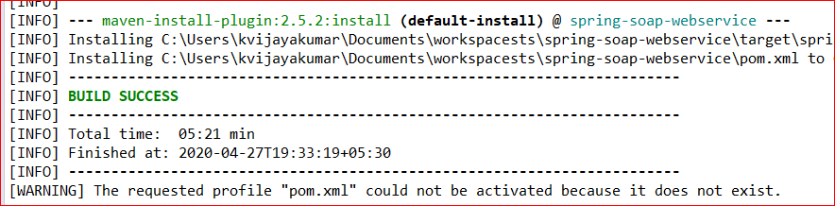

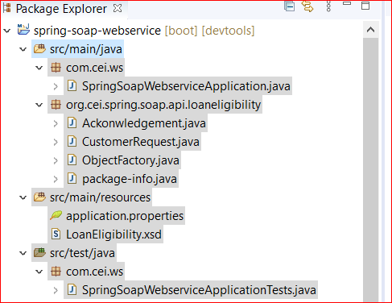

If we observe here one more package org.cei.spring.soap.api.loaneligibility has created by xjc plugin.

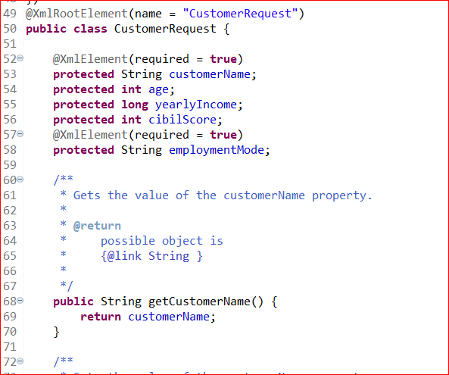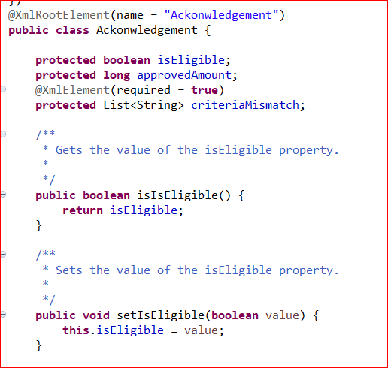

Object factory helps to instantiate the generated binding classes.

Package info is your table space.

Now we have to write the implementation.

Create packages service, endpoint, config

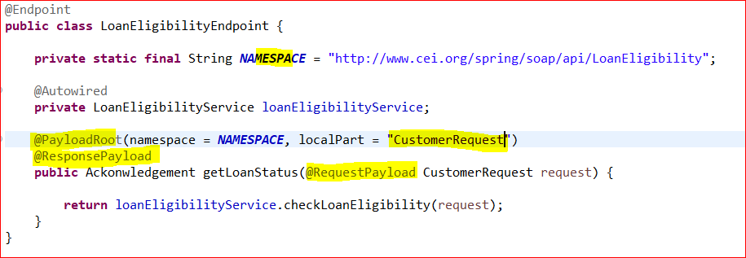

Now we need to create wsdl file but spring boot will create it automatically by providing the configuration.

So let’s create the configuration.

